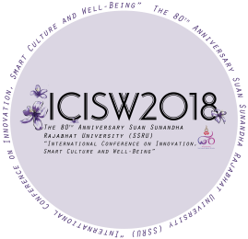***The 80th Anniversary of Suan Sunandha Rajabhat University***

***“International Conference on Innovation, Smart Culture and Well-Being” (ICISW2018),***

***November 8th, 2018,***

***Suan Sunandha Rajabhat University, Thailand***

***Dear*** .......................................,

On behalf of the organizing committee, I am pleased to inform that your abstract has been accepted and pleased to invite your participate in The 80th Anniversary of Suan Sunandha Rajabhat University

“International Conference on Innovation, Smart Culture and Well-Being” (ICISW2018), which will be held at Suan Sunandha Rajabhat University, Bangkok, Thailand, on the 8th November 2018.

***Paper title:***

***Type of presentation:***

***Paper ID:***

Please remind that the process of submission for proceeding conference and full paper publishing is separated. Full papers need to be evaluated and formatted after conference date and you will receive further information for full paper submission by email. After review process, all selected papers will be published in the journals on http://journal.ssru.ac.th/, which was indexed by Asian citation index (ACI), Thai citation index (TCI) and Google Scholar.



***Asst.Prof.Dr.Suwaree Yordchim***

***Director of the Institute of Research and Development***

***Email: conference2018@ssru.ac.th***