ACCEPTANCE LETTER
Date 10.10.2019

Dear Dr. Jitlada Chumee, Suan Sunandha Rajabhat University, Thailand
Email: jitlada.ch@ssru.ac.th

On behalf of “The 2nd Suan Sunandha National and International Academic Conference on Science and Technology (SsSci 2019)” we welcome you to join us and share your research on the theme “Science, Technology and Innovation for Sustainable Development”. We are glad to inform you that your submitted abstract entitled “The Effect of Viscosity-imparting Agent on Textural Properties of Toddy Palm Syrup” (Paper ID:sssci2019_CH_19inter) has been accepted for presentation at SsSci 2019.

You are invited to submit a full paper before 15th October 2019 for inclusion in the conference proceedings. Please visit the conference website for registration and updates.
http://conference.ssru.ac.th/sssci2019

Your interest in SsSci 2019 is very much appreciated. We look forward to meeting you at the conference.

With Warmest Regards,

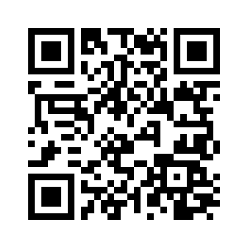 | 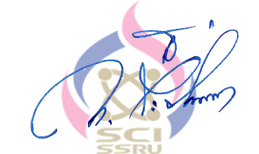  SsSci2019 Organization Committee

